Completion Certification

This is to certify that Dr./Mr./Ms. Yash Kalyani of 2022 batch of IIHMR has worked with

our organization for his/her summer internship from 4th April 2022 to 10th June 2022.

The work carried out by him/ her and performance shown by him/her during the period was found very good. This certificate is being issued to meet the requirement of the University.

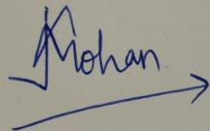

Date: 10th June 2022 (Signature of Supervisor)

Kalpana Jehan Mohan
Assistant Manager- Human Resource

